

**Photo/Video** **Waiver** **Form**

I hereby grant Eastern Michigan University and its regents, assigns, successors in interest, agents, employees, consultants and designated representatives (collectively, “EMU”), the irrevocable, perpetual, non­‐exclusive, royalty­‐free and unrestricted right and license to:

· Record my student's participation, appearance, and likeness on digital photography, videotape, audiotape, or any other form, medium or manner known now or hereafter known (collectively, the “Recordings”).

· Use my student's name (or any fictional name), likeness, photograph, portrait, voice and biographical material in connection with these Recordings.

· Reproduce, distribute, create derivative works from, publicly display, and/or publicly perform, in print, digital, electronic, web, banners, signage, or any other form, medium, or manner known now or hereafter known, copies of the Recordings, in whole or in part, including, without limitation, all originals, prints, and transparencies. This may be done without restriction as to changes or alterations, for purposes of advertising, promotion, marketing, exhibition or other lawful purposes.

I represent and warrant that I possess all rights necessary to grant this permission. I make this grant of rights voluntarily.

I acknowledge and agree I have no right, title, or interest in the Recordings, or in any negatives, digital files, tapes, disks, or other recording media used for the Recordings, or in any works derived from them. I hereby release, hold harmless, and forever discharge EMU from any and all claims, demands, actions, causes of action, suits, costs, expenses, liabilities, and damages whatsoever, in law or equity, that I, my heirs, personal representatives, or anyone acting on my behalf, have or shall have, arising out ofthe use, modification or alteration of the Recordings or works derived from them, includingbut not limited to claims for invasion of privacy or libel. I waive any right to inspect or approve any Recordings or finished products incorporating my name or likeness. This Agreement does not obligate EMU to use the Recordings in any way.

I have read this release, am fully familiar with its contents and, if desired, I have had the opportunity to review it with legal counsel. This release is governed by the laws of The State of Michigan, without giving effect to its conflict of laws principles.

I represent and warrant that I am 18 years of age or older, am competent to sign this release, and am under no legal or contractual obligation that prevents or limits me fromexecuting and performing it.

**Student** **Name: Afifa Mehak**

**Parent** **Name: Sarwat Shahnaz**

**Parent** **Signature:**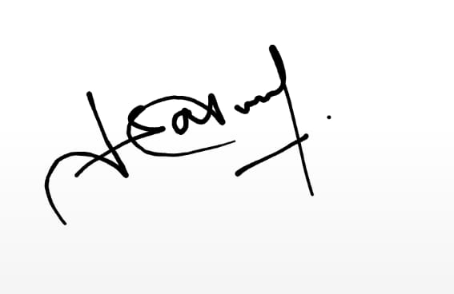

**Date:1-2-2024**

**School:**

SMB Quaid-e-Azam Public School

**Parent** **Email:sarwatnazattaria@gmail.com**